**Assignment 1**

1. What is JDK? JRE? JVM?
2. What is java compiler?
3. Why is java platform independent?
4. What is IDE? Why is it important for developers?
5. Is java case sensitive?
6. What do the following key words do?  
   static, final, public, private, void, null, package, Class, new
7. What is primitive type and reference type?
8. Is parameter passed by value or reference?
9. What is the output: System.out.println(1 > 0 : “A”:”B”);
10. How to define constants in java?
11. What is String? Is it primitive type?
12. How to check if a String is representing a number?
13. Write a program to implement the following activity diagram:

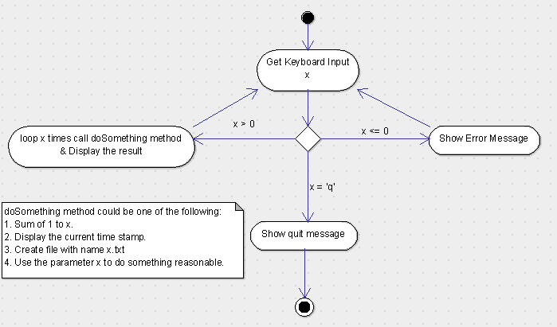

1. Write a program to merge two array of int.
2. Write a program to find the second largest number inside an array of int.